**GOOGLE EARTH ENGINE**

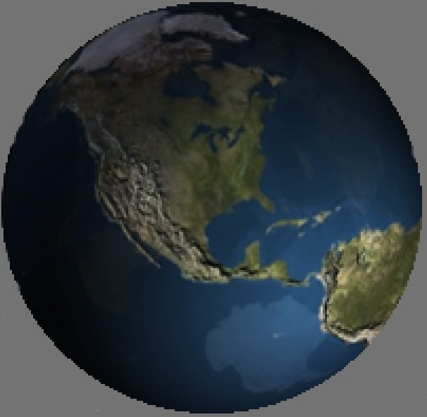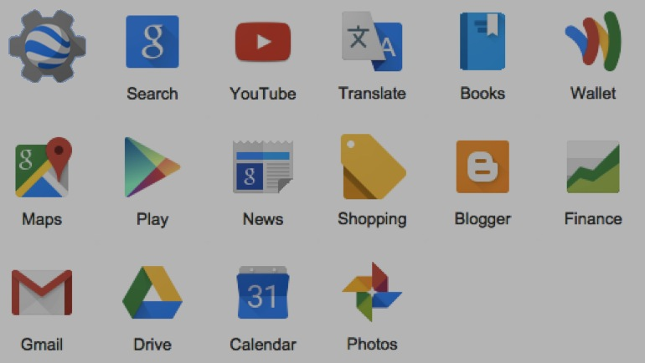**Google Earth Engine** (or EE) is one of many computer software applications developed by Google, Inc. It is currently an experimental and still-evolving platform that is fully accessible only

to those who have been approved after submitting [this form to apply](https://docs.google.com/a/google.com/forms/d/1nsrcvIJlYJSwp-rO4kAyu_yQq0YcaJmShFcmvKTIu9s/viewform" \t "_blank).

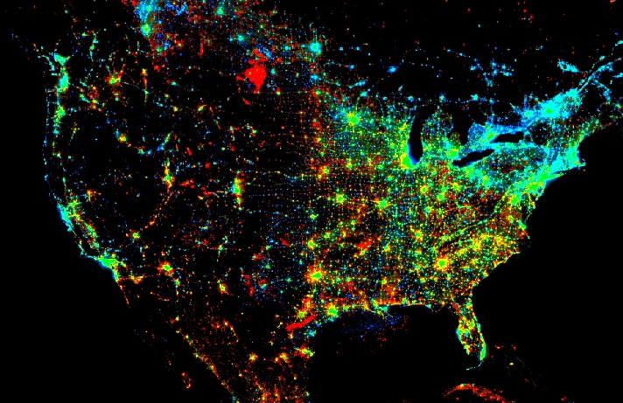

EE is related to but quite different from a popular application called **Google Earth**. Google Earth

is an Internet-based application for the visualization

of general-purpose planetary maps and aerial imagery

(as well as user-supplied cartographic data) in both

raster and vector formats. Google Earth Engine offers

capabilities that are oriented much less toward visualization

*per se* than toward the analysis and synthesis of geographical data.

It offers access to planetary maps and aerial imagery that are much more extensive and considerably more specialized than those immediately accessible through Google Earth. These include global and sub-global datasets relating to land cover, topographic elevation,

and meteorological conditions that often range over time as well as space.

EE also offers the ability to subject these datasets to analytical and synthetic operations that detect, measure, identify, characterize, or otherwise interpret geospatial conditions. Many of these capabilities are specifically associated with the classification of satellite imagery, while others are of a more general nature. Most, however, are oriented toward raster-formatted data.

EE is similar to a geographical information system (GIS) in that it organizes geospatial data into cartographic layers, each depicting variation in a particular type of geographical condition. It is also similar to a GIS in that it provides for the generation of new layers from existing layers by way of layer-processing operations that

can be combined by using the output of one as input to another.

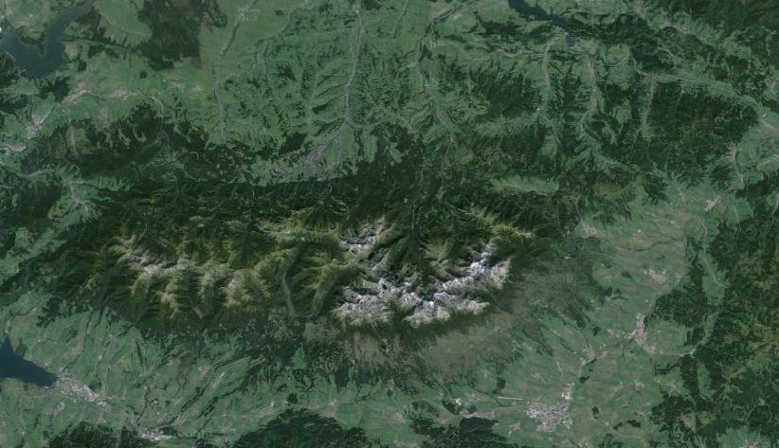

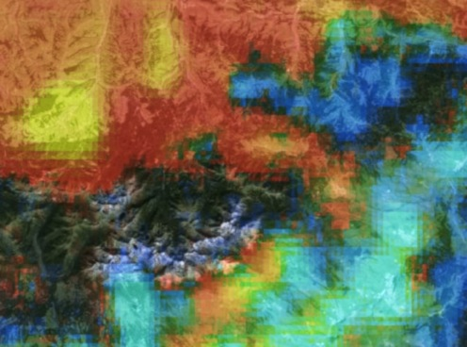EE is different from the typical GIS, however, in (at least) three conspicuous ways. First, its layers often cover the entire globe. Second, it processes those layers by utilizing large numbers of remotely accessed computers simultaneously. And third, the new layers it generates are seldom stored for subsequent use but instead merely displayed for immediate inspection. What do get stored are the sets of instructions required to regenerate those layers.

The result is what amounts to a “lens” that is able to depict a given location on the Earth’s surface

not only by presenting general-purpose data for that location but also by presenting special-purpose interpretations of those data and doing so with enough speed to rapidly browse from one such location to another. Think of it as a sort of global microscope with optical adjustments that are able to immediately analyze what’s being seen. Given data on topographic elevation, for example, such a lens might be set to set to depict topographic slope, aspect, shaded relief, ridges, valleys, flood-prone areas, and so on. As this lens is directed toward new locations, it is constantly processing new topographic data on the fly.

The three major components of Earth Engine are introduced below. Respectively, these relate to 1) data, 2) data processing, and 3) data-processing control.

**GOOGLE EARTH ENGINE**

DATA

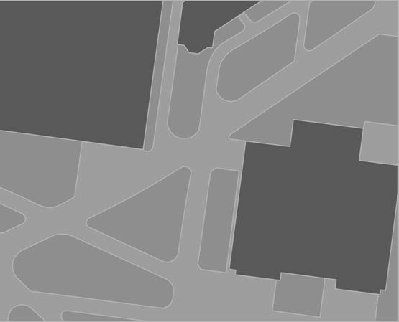Google Earth Engine is designed to process geospatial data of particular types and to organize its data in particular

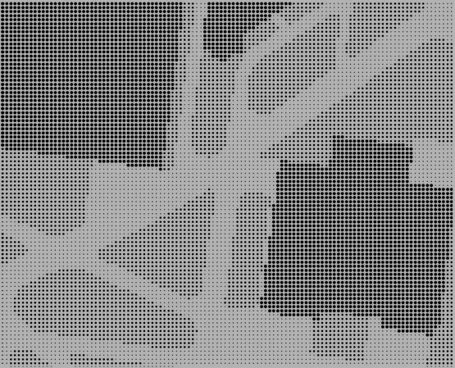 ways.

All EE data are stored in an online **Data Catalog** maintained by Google, where they are accessible in units called

**Datasets** or **Assets**.

Here, each dataset is referred to by way of a descriptive

name (like “Landsat 7 32-Day EVI Composite) and a more

cryptic **Asset ID** (like “LANDSAT/LE7\_L1T\_32DAY\_EVI).

Each dataset also has a **Projection** (coordinate system) and may include **Metadata** describing its format, its authors, its date, its precision, and so on.

Four major types of dataset are available, including - **Features**,

- **Images**,

- **Feature Collections**, and

- **Image Collections**.

A **Feature** **Dataset** records geographical conditions as point, line, or An **Image Dataset** (or, more simply, an **Image**)differs from

or polygon **geometries** that are associated with recorded properties. a feature dataset in much the same way that a photograph

Feature datasets play only auxiliary roles in Google Earth Engine, differs from a drawing. Whereas a feature dataset describes

which is primarily oriented toward images and image collections. the world in terms of points, lines, or polygons, an image

dataset does so in terms of **Pixels** (“picture elements”).

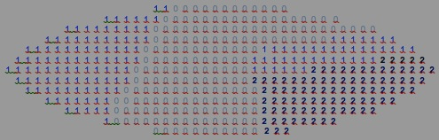A pixel is one of a set of sample locations that cover

a geographical area in a regular pattern of perpendicular

rows and columns.

The simplest type of image is one on which each pixel records

a single numerical **Value** to represent its geographical location,

and the set of such values for all pixels can be envisioned as

a “checkerboard” of numbers. **Values** can be stored as integers (of signed or unsigned 8-bit, 16-bit, 32-bit, or 64-bit precision) or as a floating-point numbers (of single or double precision) as long as all values of the same image are of the same type.

The set of all pixels that share a common value is referred to as a **Region**, which may correspond, for example, to a particular type of land cover like “softwood forest.”

**GOOGLE EARTH ENGINE**

DATA

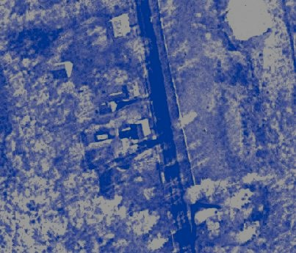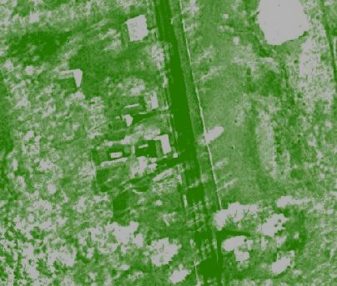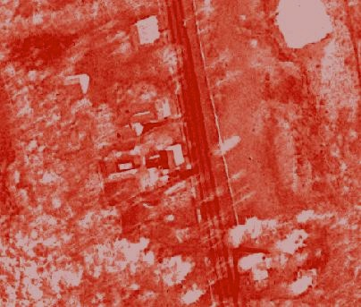A somewhat more complex type of image is one on which each pixel records multiple values in order to represent multiple characteristics of its location. In this case, all pixels of the same image must record the same number of values, and the set of every pixel’s Nth value is referred to as one of that image’s **Bands**. An image of this type is in fact called a **Multiband** imageas opposed to the **Singleband**

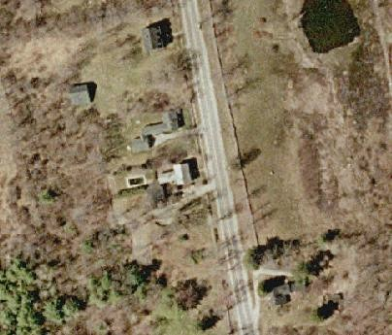image type of image described initially.

Multiband images are often used to store combinations of values representing the intensities

of different colors, each color being a “band” of wavelengths on the electromagnetic spectrum and explaining the use of that term. This is also routinely done in digital color photography

where each pixel’s color is expressed in terms of its redness, greenness, and blueness.

Since airborne sensors are able to sense and record more bands of electromagnetic radiation than is the human eye, “multispectral” satellite images often include more or (in the case of “hyperspectral” images, many more) bands per image.

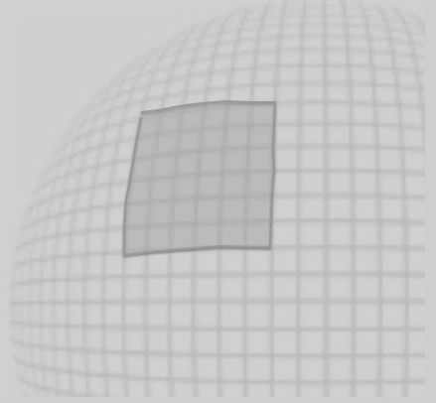Every band of an image is also accompanied by an auxiliary band called a **Mask** on which

each pixel’s value indicates, on a scale ranging from 0 to 1, the degree to which that pixel

should be regards as transparent (0), opaque (1), or translucent to a specified degree (0-1).

Images covering large portions of the globe often stored as a “patchwork” of adjacent,

rectangular **scenes** that can be accessed individually but are more often regarded

as part of a seamless “quilt.”

Both features and images can be accessed in groupings called **collections**, each of which

usually contains datasets that are related to one another by location, time, and/or content.

Image collections are often used to hold images depicting the same conditions for the same

locations but do so at different points in time.

**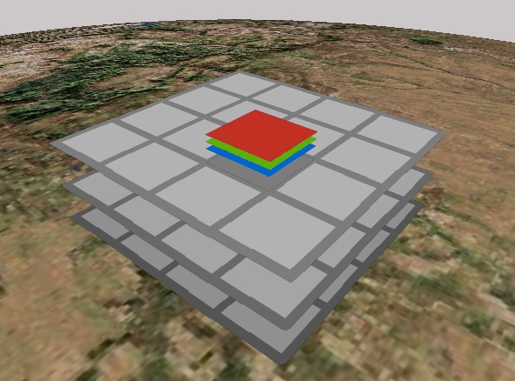**

This type of image collection could be envisioned as comparable to

- a set of patchwork quilts (as represented by the three gray patchworks to the left),with

- each patch (individual gray square) corresponding to a single scene that could well include

- multiple bands (as shown in red, green, and blue)

As strained as this quilt analogy may be, it is actually quite important that you be able to envision

the sometimes-complex structure of an image collection, because image collections are in fact

the most common type of dataset employed in Google Earth Engine.

**GOOGLE EARTH ENGINE**

DATA PROCESSING

In order to understand the large and varied set of data-processing capabilities available through Google Earth Engine, it is useful to envision those capabilities

in terms of their effects on the transfer of data among four major environments that are respectively called a **Server**, a **Client**, a **Disk**, and a **Monitor**.

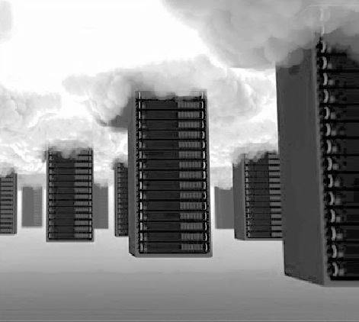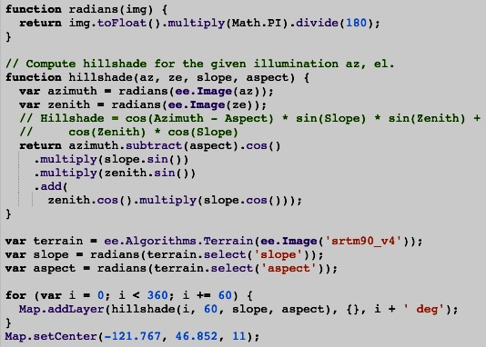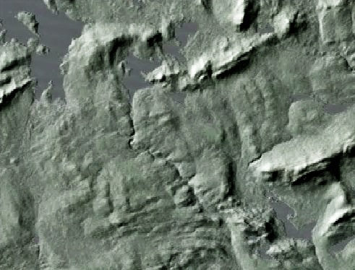**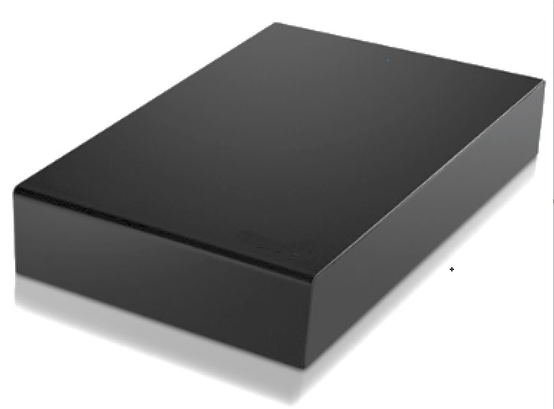**

A **Client** is a local computer from which a user can access an EE Server, a local Disk, and a local Monitor.

A **Server** is a large and powerful data storage and processing facility

that is maintained by Google and generally accessible online.

.

**CLIENT**

**VARIABLES**

**DATASETS**

Here, geographical data

are organized as **Datasets**.

Variables can

also be generated

directly from

user input.

**DISK**

Files can

of course also

be generated

independently.

**FILES**

**LAYERS**

Here, Layers exported

from a Client can be

saved as **Files**.

**SERVER**

Here, Datasets are

represented as **Variables**.

A large number of

Datasets have

been compiled

by Google.

Datasets can also be generated

by users from certain types of Files.

A **Monitor** is the local input/output

device accessible to an individual user.

A **Disk** is the local data storage and retrieval

facility accessible to an individual user.

**MONITOR**

**GOOGLE EARTH ENGINE**

Here, Variables maintained by a Client can be presented

in graphic, cartographic, or text format as **Layers**.

DATA-PROCESSING CONTROL

Control over the processing capabilities of Google Earth Engine

can be exercised through either of two applications respectively called the EE [**Graphical Users Interface** (**GUI**)](EE02%20%20%20The%20EE%20GUI.docx)  and

the EE [**Application Programming Interface (API)**](EE05%20%20%20The%20EE%20API.docx) .

Each of these applications operates as a web service and does so best when accessed using the Google’s **Chrome** web browser (available [here](https://support.google.com/chrome/answer/95346?hl=en)).

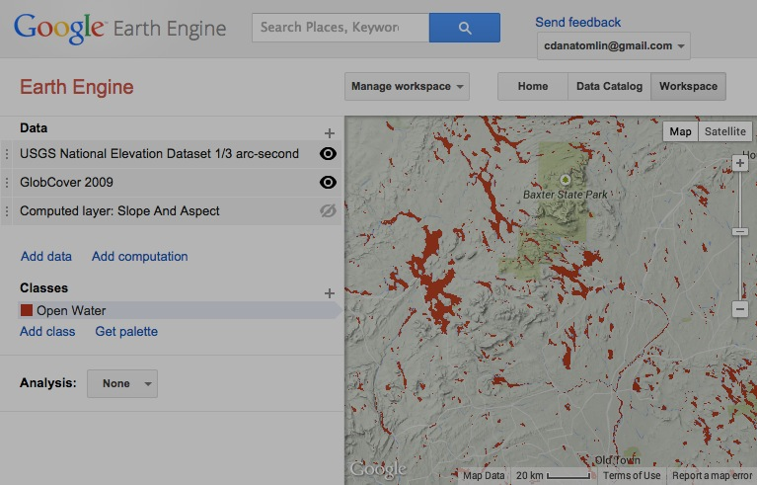The EE GUI offers only a subset of the capabilities that are available through the EE API,

but it offers them in a manner that requires less expertise. Among these are capabilities relating to

- the **Execution** of instructions and the management of instruction sets,

- the **Navigation** of geographic space in order to focus the map display,

- the **Acquisition** of cloud datasets stored presenting them as map layers,

- the **Generation** of new map layers by uploading disk files or reading onscreen input,

- the **Computation** of new map layers by way of specified operations,

- the **Presentation** of map layers onscreen,

- the **Reproduction** of map layers as disk files

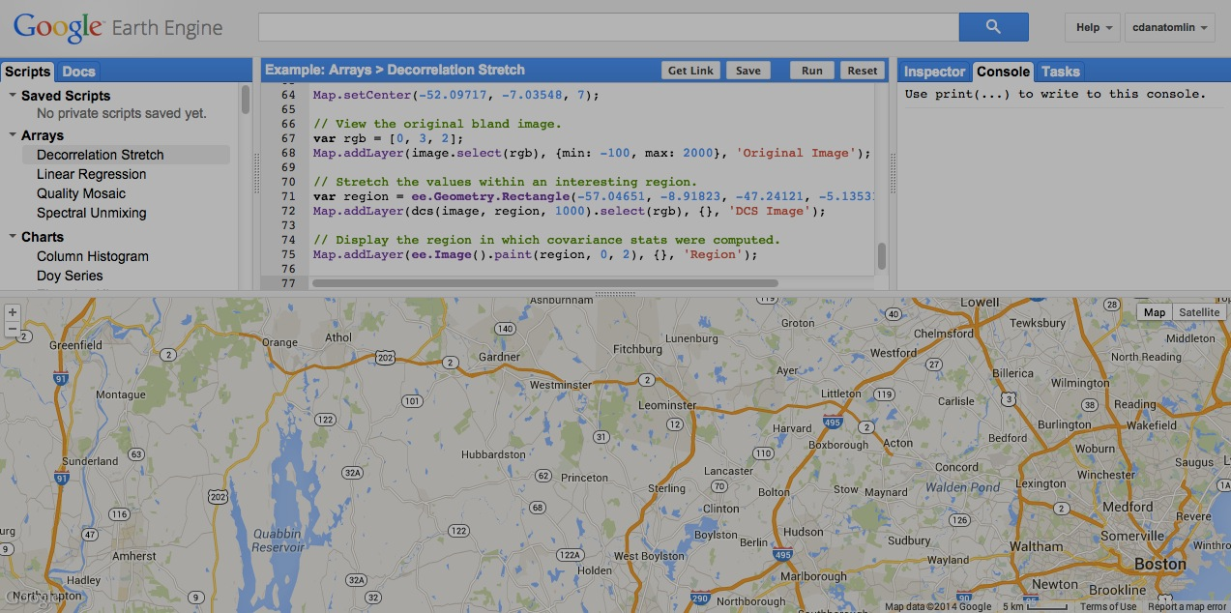

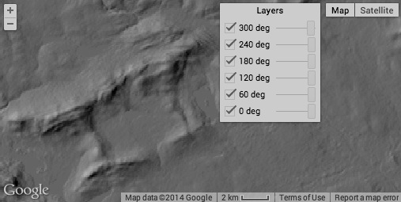

The EE API offers the same types of capability but does so

through either the JavaScript or Python programming languages.

As such, it provides more flexible control over a wider range

of more specialized processing options, but it also requires

familiarity with one of those programming languages.

Like many application programming interfaces, the EE API

is sometimes referred to as a “playground,” and the reasons

for this are significant. Though mastery of its equipment

will indeed require practice, that practice needn’t be

anything but fun, particularly when there are other kids

nearby.